As the previous chapter mention there are many items in the cgroup system. How these items is describe in the kernel.

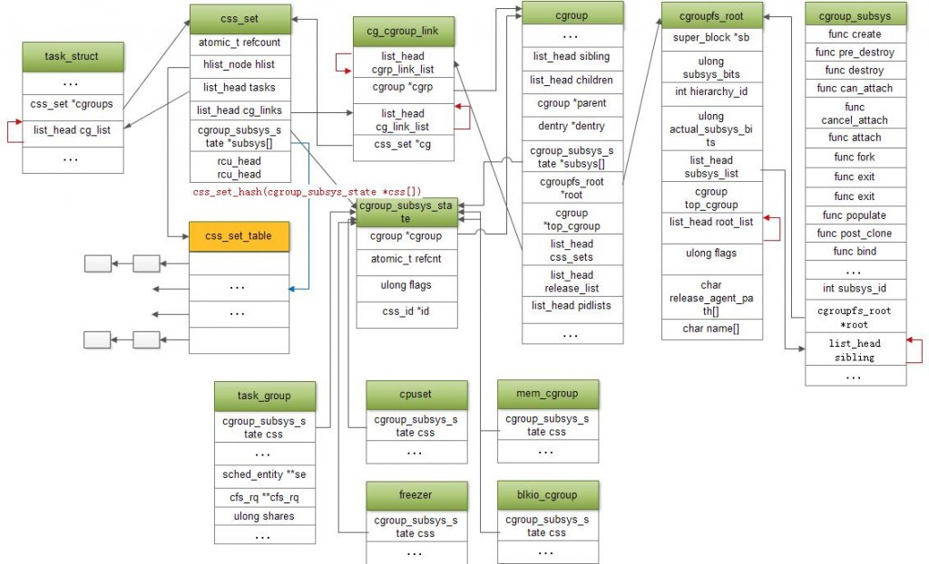

1. Root

Root is described by struct cgroupfs_root

struct cgroupfs_root {

……

/* The bitmask of subsystems intended to be attached to this hierarchy */

unsigned long subsys_mask;

/* A list running through the attached subsystems */

struct list_head subsys_list;

/* The default/top cgroup for this hierarchy */

struct cgroup top_cgroup;

/* A list running through the active hierarchies/Root */

struct list_head root_list;

/* All cgroups on this root */

struct list_head allcg_list;

……

};

1. Subsystem

Subsystem is described by struct cgroup_subsystem

struct cgroup_subsys {

int subsys_id; /*id*/

const char *name; /*name*/

struct cgroupfs_root *root; /*which Root this subsys belong to*/

struct list_head sibling; /*link each subsystem in the same Root*/

struct cftype *base_cftypes; /*describe the subsystem files operations*/

struct cftype_set base_cftset;

};

struct cftype {

char name[MAX_CFTYPE_NAME];

int (*open)(struct inode *inode, struct file *file);

ssize_t (*read)(struct cgroup *cgrp, struct cftype *cft,

struct file *file,

char __user *buf, size_t nbytes, loff_t *ppos);

ssize_t (*write)(struct cgroup *cgrp, struct cftype *cft,

struct file *file,

const char __user *buf, size_t nbytes, loff_t *ppos);

}

In Linux kernel the subsystem is static defined, it contains the following subsystems.

#define SUBSYS(_x) extern struct cgroup_subsys _x ## _subsys;

static struct cgroup_subsys *subsys[CGROUP_SUBSYS_COUNT] = {

SUBSYS(cpuset) //struct cgroup_subsys cpuset_subsys

SUBSYS(debug) //struct cgroup_subsys debug_subsys

SUBSYS(cpu_cgroup) //struct cgroup_subsys cpu_cgroup_subsys

SUBSYS(cpuacct) //struct cgroup_subsys cpuacct_subsys

SUBSYS(mem_cgroup) //struct cgroup_subsys mem_cgroup_subsys

SUBSYS(devices) //struct cgroup_subsys devices_subsys

SUBSYS(freezer) //struct cgroup_subsys freezer_subsys

SUBSYS(net_cls) //struct cgroup_subsys net_cls_subsys

SUBSYS(blkio) // struct cgroup_subsys blkio_subsys

SUBSYS(perf) //struct cgroup_subsys perf_subsys

SUBSYS(net_prio) //struct cgroup_subsys net_prio_subsys

SUBSYS(hugetlb) //struct cgroup_subsys hugetlb_subsys

};

1. group

Group is described by struct cgroup

struct cgroup {

struct list_head sibling; /* my parent's children */

struct list_head children; /* my children */

struct cgroup *parent; /* my parent */

/* Private pointers for each registered subsystem */

struct cgroup_subsys_state *subsys[CGROUP_SUBSYS_COUNT];

struct cgroupfs_root *root; /*which Root this group belong to*/

struct cgroup *top_cgroup; /*point to the default/top group in the Root*/

/* List of cg_cgroup_links pointing at css_sets with tasks in this group , css_set talked later*/

struct list_head css_sets;

struct list_head allcg_node; /* link to cgroupfs_root->allcg_list */

}

1. Tasks

A group contains several tasks/processes. A task only belongs to one of the group in a Root. In the default all tasks belong to the top group in this Root. But a task can belong to different groups in different Roots.

How a task associates with these groups?

task_struct{

/* A css_set is a structure holding pointers to a set of cgroup_subsys_state objects */

struct css_set __rcu *cgroups;

/* cg_list is link to css_set->tasks */

struct list_head cg_list;

};

Task don’t communicate with groups directly. It contains a css_set structure and a list linked to the css_set.

A task has only one css_set. But a css_set may belong to multiple tasks because tasks may have the same subsystem resources and belong to the same group in different Roots. These tasks matched above situation share the same css_set. The css_set contains subsys state object that can control each subsystem resources.

struct css_set {

/ * List running through all cgroup groups in the same hash slot */

struct hlist_node hlist;

/*List running through all tasks using this css_set*/

struct list_head tasks;

/*List of cg_cgroup_link objects on link chains from

cgroups referenced from this css_set */

struct list_head cg_links;

struct cgroup_subsys_state *subsys[CGROUP_SUBSYS_COUNT];

};

A css_set may belong to multiple groups in different Root because a task maybe attach to different Root. Also a group may have multiple css_set because a group attach by multiple task whose css_set may different.

How do css_set associate with group?

struct cg_cgroup_link {

/*List running through cg_cgroup_links associated with a

cgroup, link to cgroup->css_sets */

struct list_head cgrp_link_list;

struct cgroup *cgrp;

/*List running through cg_cgroup_links pointing at a

single css_set object, link to css_set->cg_links*/

struct list_head cg_link_list;

struct css_set *cg;

};

So user can get the tasks in a specific group as following. Get each cg_cgroup_link through traversing on cgroup-> css_sets, then find the css_set through cg_cgroup_link->cg, finally traverse each task through css_set->tasks.

Also user can check which group and Root this task attach to as following. Find the css_set through task->css_set, then get each the cg_cgroup_link through traversing css_set->cg_links, finally get cgroup through cg_cgroup_link->cgrp.

1. Subsystem object

struct cgroup_subsys_state as the base structure to describe each subsystem object that contain the subsystem resources control and management objects .

struct cgroup_subsys_state {

/*The cgroup that this subsystem is attached to. */

struct cgroup *cgroup;

};

1. Cpuset

struct cpuset {

struct cgroup_subsys_state css;

cpumask_var_t cpus_allowed; /* CPUs allowed to tasks in cpuset */

nodemask_t mems_allowed; /* Memory Nodes allowed to tasks */

};

static inline struct cpuset *cgroup_cs(struct cgroup *cont)

{

return container_of(cgroup_subsys_state(cont, cpuset_subsys_id),

struct cpuset, css);

}

static inline struct cpuset *task_cs(struct task_struct *task)

{

return container_of(task_subsys_state(task, cpuset_subsys_id),

struct cpuset, css);

}

1. Memory

struct mem_cgroup {

struct cgroup_subsys_state css;

/…

};

static inline

struct mem_cgroup *mem_cgroup_from_css(struct cgroup_subsys_state *s)

{

return container_of(s, struct mem_cgroup, css);

}

1. Cpuacct

struct cpuacct {

struct cgroup_subsys_state css;

/* cpuusage holds pointer to a u64-type object on every cpu */

u64 __percpu *cpuusage;

struct kernel_cpustat __percpu *cpustat;

};

static inline struct cpuacct *cgroup_ca(struct cgroup *cgrp)

{

return container_of(cgroup_subsys_state(cgrp, cpuacct_subsys_id),

struct cpuacct, css);

}

static inline struct cpuacct *task_ca(struct task_struct *tsk)

{

return container_of(task_subsys_state(tsk, cpuacct_subsys_id),

struct cpuacct, css);

}

1. Devices

struct dev_cgroup {

struct cgroup_subsys_state css;

struct list_head exceptions;

enum {

DEVCG_DEFAULT_ALLOW,

DEVCG_DEFAULT_DENY,

} behavior;

};

static inline struct dev_cgroup *cgroup_to_devcgroup(struct cgroup *cgroup)

{

return css_to_devcgroup(cgroup_subsys_state(cgroup, devices_subsys_id));

}

static inline struct dev_cgroup *task_devcgroup(struct task_struct *task)

{

return css_to_devcgroup(task_subsys_state(task, devices_subsys_id));

}

1. freezer

enum freezer_state {

CGROUP_THAWED = 0,

CGROUP_FREEZING,

CGROUP_FROZEN,

};

struct freezer {

struct cgroup_subsys_state css;

enum freezer_state state;

spinlock_t lock; /* protects _writes_ to state */

};

static inline struct freezer *cgroup_freezer(

struct cgroup *cgroup)

{

return container_of(

cgroup_subsys_state(cgroup, freezer_subsys_id),

struct freezer, css);

}

static inline struct freezer *task_freezer(struct task_struct *task)

{

return container_of(task_subsys_state(task, freezer_subsys_id),

struct freezer, css);

}